Exercise: Data and Authentication
Submit your solutions in the SoftUni judge system at:
https://alpha.judge.softuni.org/contests/data-and-authentication-exercise/3467
Working with Remote Data
For the solution of some of the following tasks, you will need to use an up-to-date version of the local REST service, provided in the lesson’s resources archive. You can read the documentation here.

Messenger
Write a JS program that records and displays messages. The user can post a message, supplying a name and content and retrieve all currently recorded messages.
The url for the requests - http://localhost:3030/jsonstore/messenger
When [Send] button is clicked you should create a new object and send a post request to the given url. Use the following message structure:
{
author: authorName,
content: msgText,
}
If you click over [Refresh] button you should get all messages with GET request and display them into the textarea. Use the following message format:
"{author}: {message}"

Examples
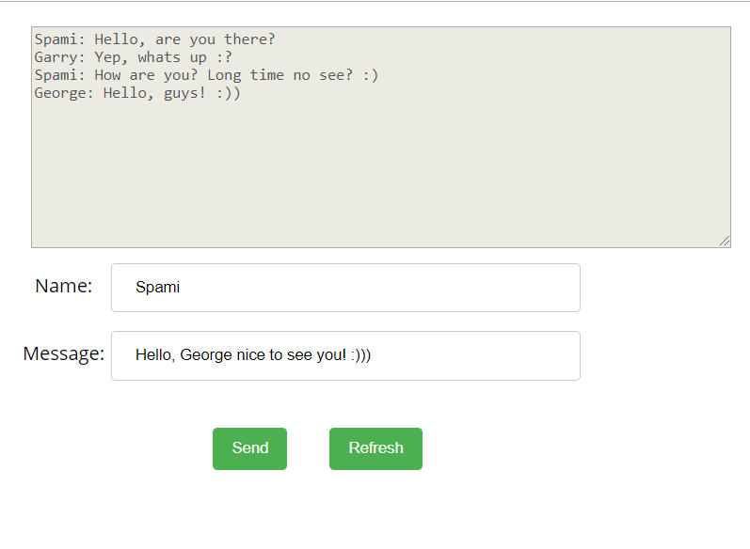
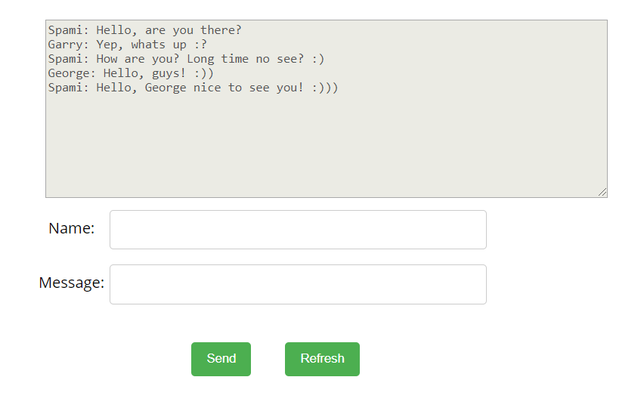

Phonebook

Write a JS program that can load, create and delete entries from a Phonebook. You will be given an HTML template to which you must bind the needed functionality.
When the [Load] button is clicked, a GET request should be made to the server to get all phonebook entries. Each received entry should be in a li inside the ul with id="phonebook" in the following format with text "<person>: <phone> " and a [Delete] button attached. Pressing the [Delete] button should send a DELETE request to the server and delete the entry. The received response will be an object in the following format:
{<key>:{person:<person>, phone:<phone>}, <key2>:{person:<person2>, phone:<phone2>,…} where <key> is an unique key given by the server and <person> and <phone> are the actual values.
When the [Create] button is clicked, a new POST request should be made to the server with the information from the Person and Phone textboxes, the Person and Phone textboxes should be cleared and the Phonebook should be automatically reloaded (like if the [Load] button was pressed).
The data sent on a POST request should be a valid JSON object, containing properties person and phone. Example format:
{
"person": "<person>",
"phone": "<phone>"
}
The url to which your program should make requests is:
http://localhost:3030/jsonstore/phonebook
GET and POST requests should go to http://localhost:3030/jsonstore/phonebook, while DELETE requests should go to http://localhost:3030/jsonstore/phonebook/:key , where :key is the unique identifier of the entry (you can find this key in the response data from the GET request, usually under a property like _id).
Note: When you receive data from the GET request, each record will have an _id property that contains the unique identifier needed for the DELETE operation. Use record._id to construct the DELETE URL.

Screenshots:
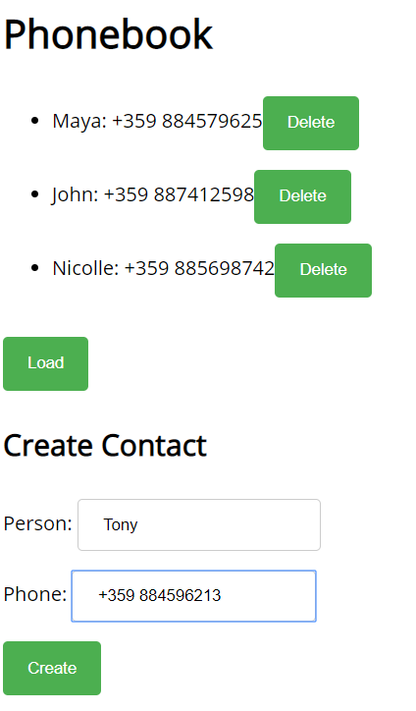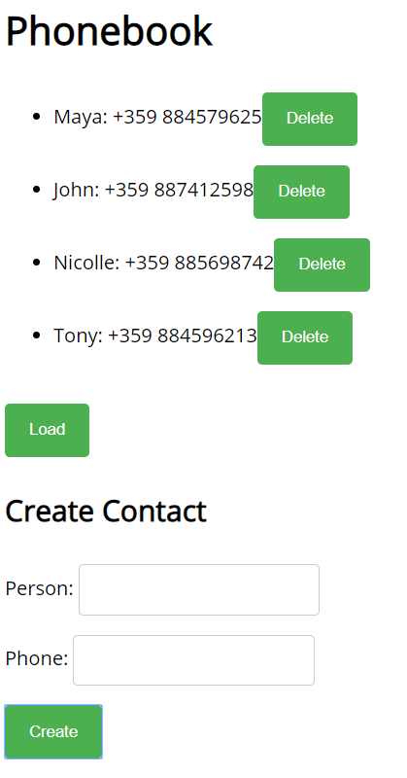

Students
Your task is to implement functionality for creating and listing students from a database. Create a new collection called "students",
Each student has:
- firstName - string, non-empty
- lastName - string, non-empty
- facultyNumber - string of numbers, non-empty
- grade - string of number, non-empty
You need to write functionality for creating students. When creating a new student, make sure you name the properties accordingly.
You will also need to extract students. You will be given an HTML template with a table in it. Create an AJAX request that extracts all the students.
URL for this task: http://localhost:3030/jsonstore/collections/students

Screenshots
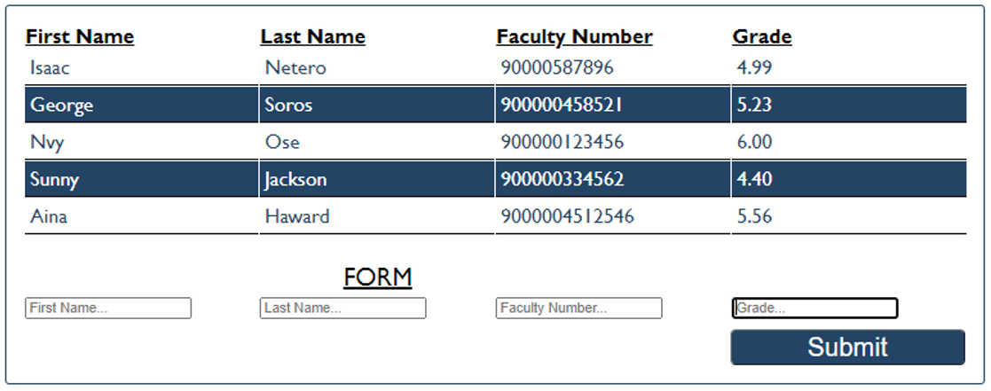

Book Library

First task is to "GET" all books. To consume the request with POSTMAN your url should be the following: http://localhost:3030/jsonstore/collections/books
Using the provided skeleton, write the missing functionalities.
Load all books by clicking the button "LOAD ALL BOOKS"
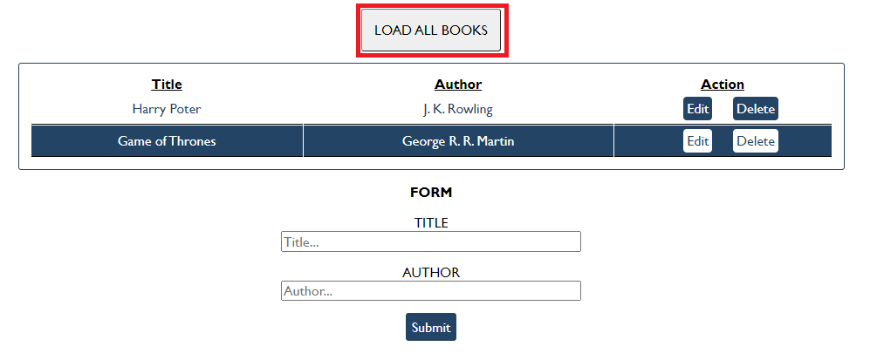

Get Book
This functionality is not needed in this task, but you can try it with postman by sending request to "GET" the Book with id:" d953e5fb-a585-4d6b-92d3-ee90697398a0". Send a GET request to this URL:
http://localhost:3030/jsonstore/collections/books/:id

Create Book
Write functionality to create a new book, when the submit button is clicked. Before sending the request be sure the fields are not empty (make validation of the input). To create a book, you have to send a "POST" request and the JSON body should be in the following format:
{
"author": "New Author",
"title": "New Title"
}

Update Book
By clicking the edit button of a book, change the form like this:
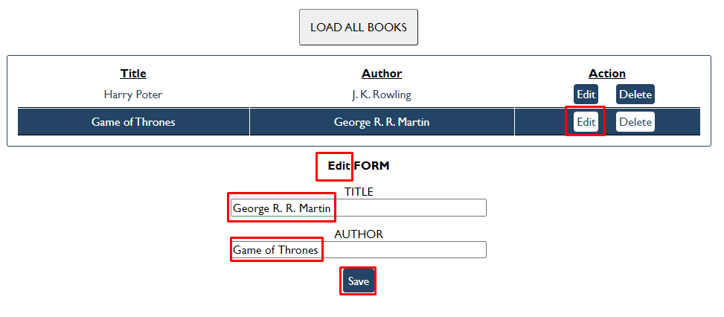

The HTTP command "PUT" modifies an existing HTTP resource. The URL is:
http://localhost:3030/jsonstore/collections/books/:id
The JSON body should be in the following format:
{
"author": "Changed Author",
"title": "Changed Title"
}

Delete Book
By clicking the delete button you have to delete the book, without any confirmation. To delete a book use "DELETE" command and send REQUEST: http://localhost:3030/jsonstore/collections/books/:id

Fisher Game
Use the provided skeleton and the server.
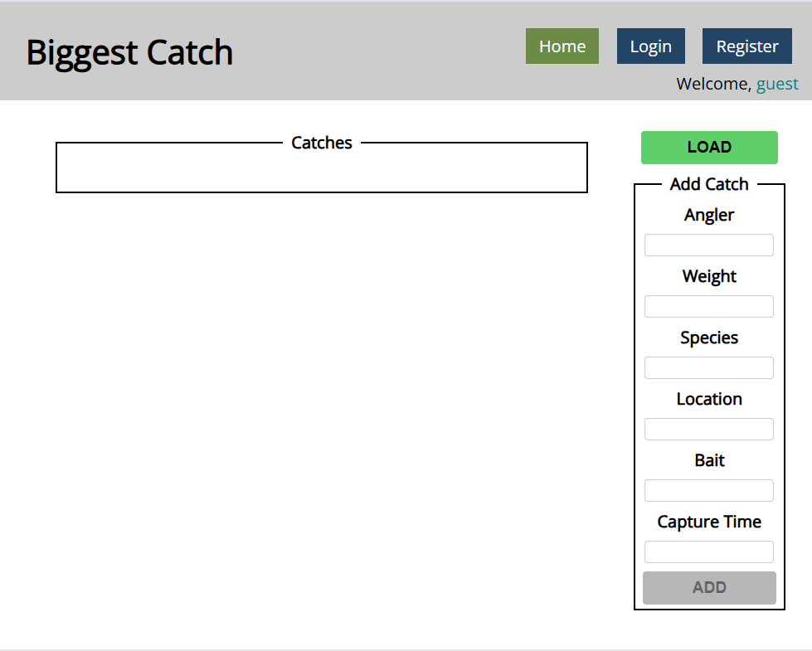

Login User
The Login page contains a form for existing user authentication. By given username and password, the app should login an existing user.
- After a successful login the home page should be displayed.
- In case of error, an appropriate error message should be displayed and the user should be able to fill in the login form again.
- Keep the user data in the browser's session or locale storage.
- Get request: http://localhost:3030/users/login
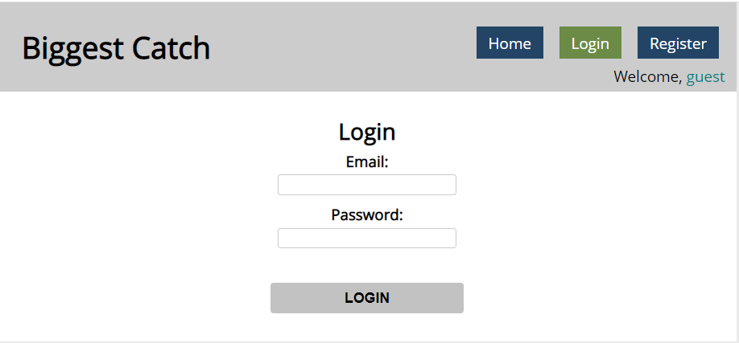
If the user is not logged in, all the buttons should be disabled except the "LOAD" button.

Register User
By given email and password, the app should register a new user in the system.
- In case of error (eg. invalid username/password), an appropriate error message should be displayed, and the user should be able to try to register again.
- Keep the user data in the browser's session or local storage.
- After a successful registration the home page should be displayed.
- Post request: http://localhost:3030/users/register
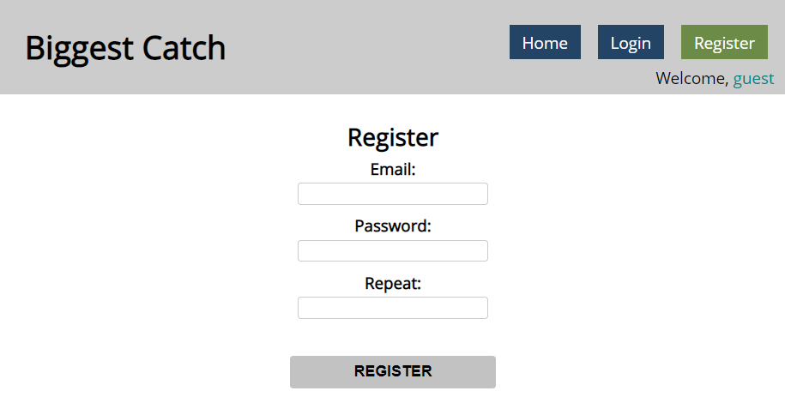

Logout
The logout action is available to logged-in users. Send the following request to perform logout:
- Get: http://localhost:3030/users/logout
Required headers are described in the documentation. Upon success, the REST service will return an empty response. Clear any session information you’ve stored in browser storage.
If the logout was successful, redirect the user to the Home page and change the button in navigation.

Load catches
By clicking it you have to load all the catches from the server and render them like on the picture:
- Pressing the [Load] button should list all catches. (For all users)
- Pressing the [Update] button should send a PUT request, updating the catch in http://localhost:3030/data/catches/:id. (Only for the creator of the catch)
- Pressing the [Delete] button should delete the catch from http://localhost:3030/data/catches/:id. (Only for the creator of the catch)
- Pressing the [Add] button should submit a new catch with the values of the inputs in the fieldset with id="addFrom". (Only for logged in users)
- Button [Add] should be disabled in there are no logged in user.
- Buttons [Update] and [Delete] should be disabled if the currently logged-in user is not the author of the catch.

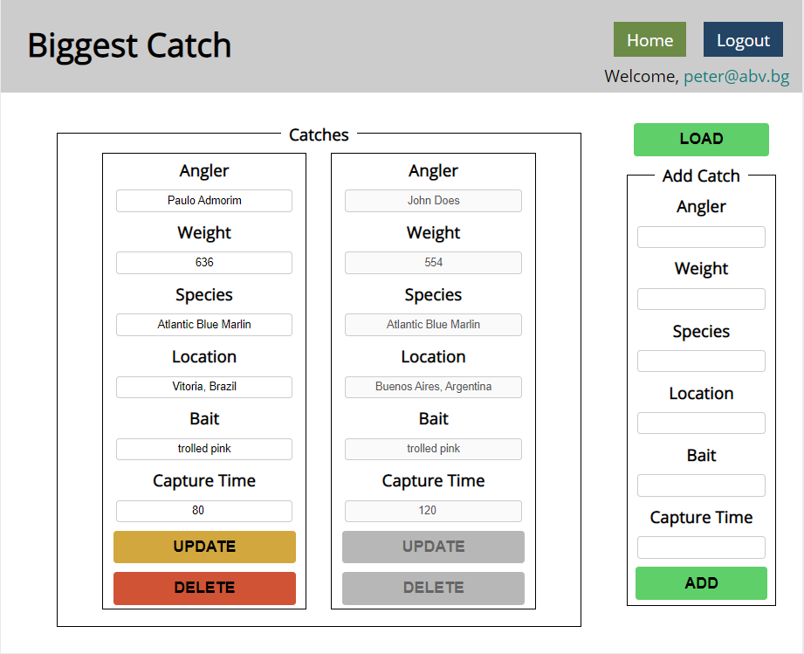
Each catch should have:
- angler - string representing the name of the person who caught the fish
- weight - floating-point number representing the weight of the fish in kilograms
- species - string representing the name of the fish species
- location - string representing the location where the fish was caught
- bait - string representing the bait used to catch the fish
- captureTime - integer number representing the time needed to catch the fish in minutes
Use the following requests to access your data:
- List All Catches
  - Endpoint - http://localhost:3030/data/catches
  - Method: GET
- Create a New Catch
  - Endpoint: http://localhost:3030/data/catches
  - Method: POST
  - Request body (JSON): {"angler":"…", "weight":…, "species":"…", "location":"…", "bait":"…", "captureTime":…}
- Update a Catch
  - Endpoint: http://localhost:3030/data/catches/:catchId
  - Method: PUT
  - Request body (JSON): {"angler":"…", "weight":…, "species":"…", "location":"…", "bait":"…", "captureTime":…}
- Delete a Catch
  - Endpoint: http://localhost:3030/data/catches /:catchId
  - Method: DELETE

Furniture *
Your task is to write the functionality of app, which shows list of furniture. By logged in user there is a possibility to buy furniture and list the bought products of the logged user. Also logged user can create new products (offers).
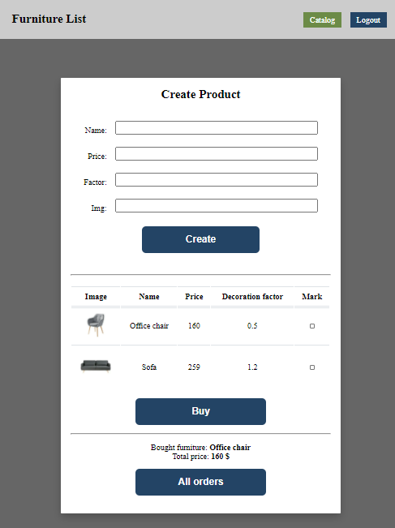

Home page (not logged)
When the page is loaded the app should list all the furnitures in a table:
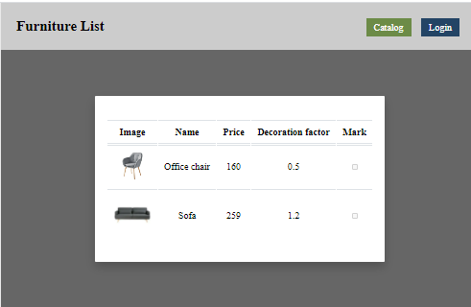
The checkbox should be disabled. You can send GET request on the URL: http://localhost:3030/data/furniture

Auth page
When "Login" is clicked, the app should redirect to "Login page". There are two possibilities:
- to register a new user, send a POST request to the URL: http://localhost:3030/users/register
- to login, send a POST request to the URL: http://localhost:3030/users/login
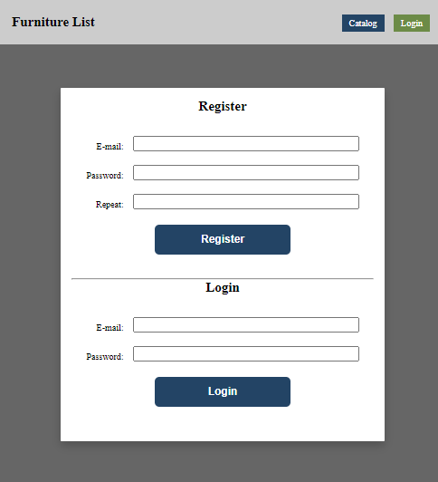

Home page (logged in)
When the "Create" button is clicked, add a new row to the table for each piece of furniture with name, price, factor and img. Send POST request to: http://localhost:3030/data/furniture
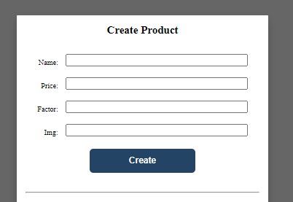
When the "Buy" button is clicked, get all checkboxes that are marked and save the information for these orders on the server. Make POST request to: http://localhost:3030/data/orders
When the "All orders" button is clicked, get all bought furniture of the current user, and show their names and the total price, as shown on the picture:
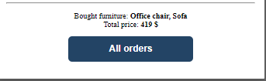
This could happen with GET request on this URL: http://localhost:3030/data/orders?where=_ownerId%3D{userId}

Submitting Your Solution
Place in a ZIP file the content of the given resources including your solution. Exclude the node_modules folder if there is one. Upload the archive to Judge.
